Assignment_2
Creation of EPIC 1-Design
https://pavithra222cp.atlassian.net/browse/SCRUM-7
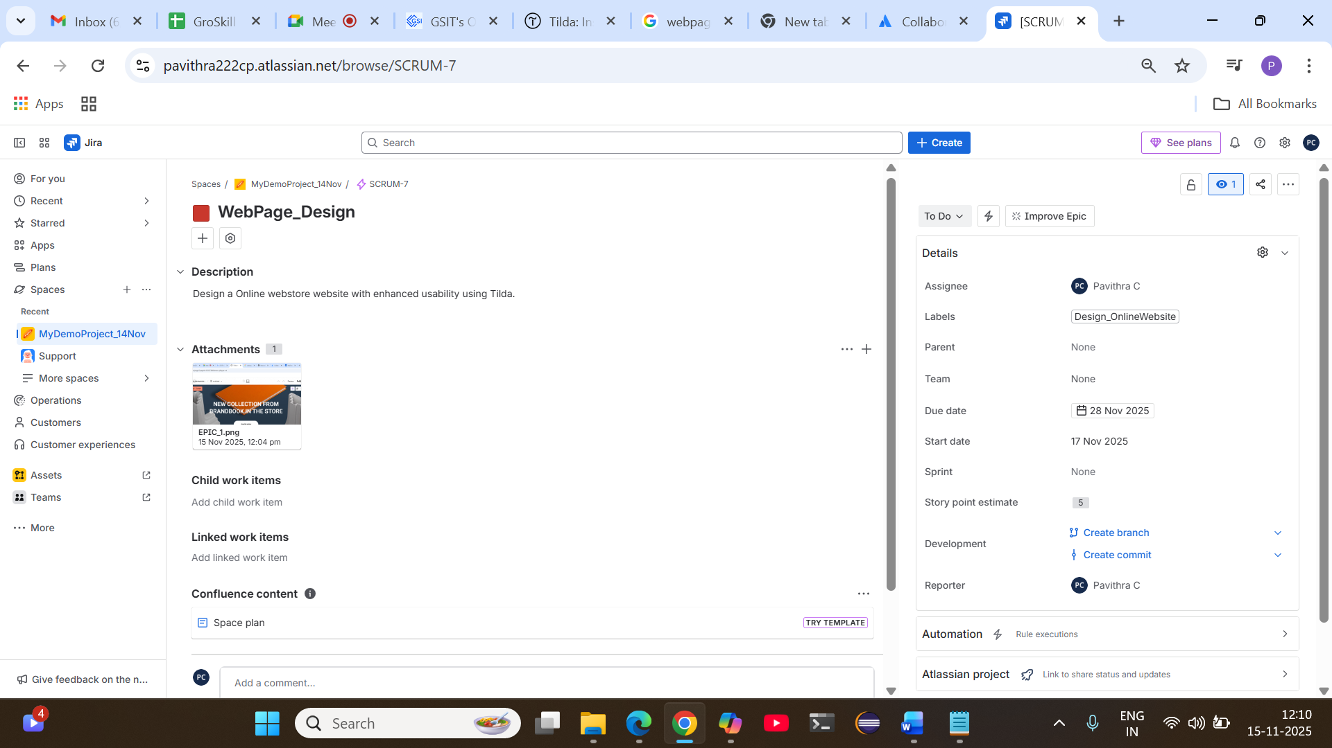
Adding User story 1-Webpage layout implementation
https://pavithra222cp.atlassian.net/browse/SCRUM-8

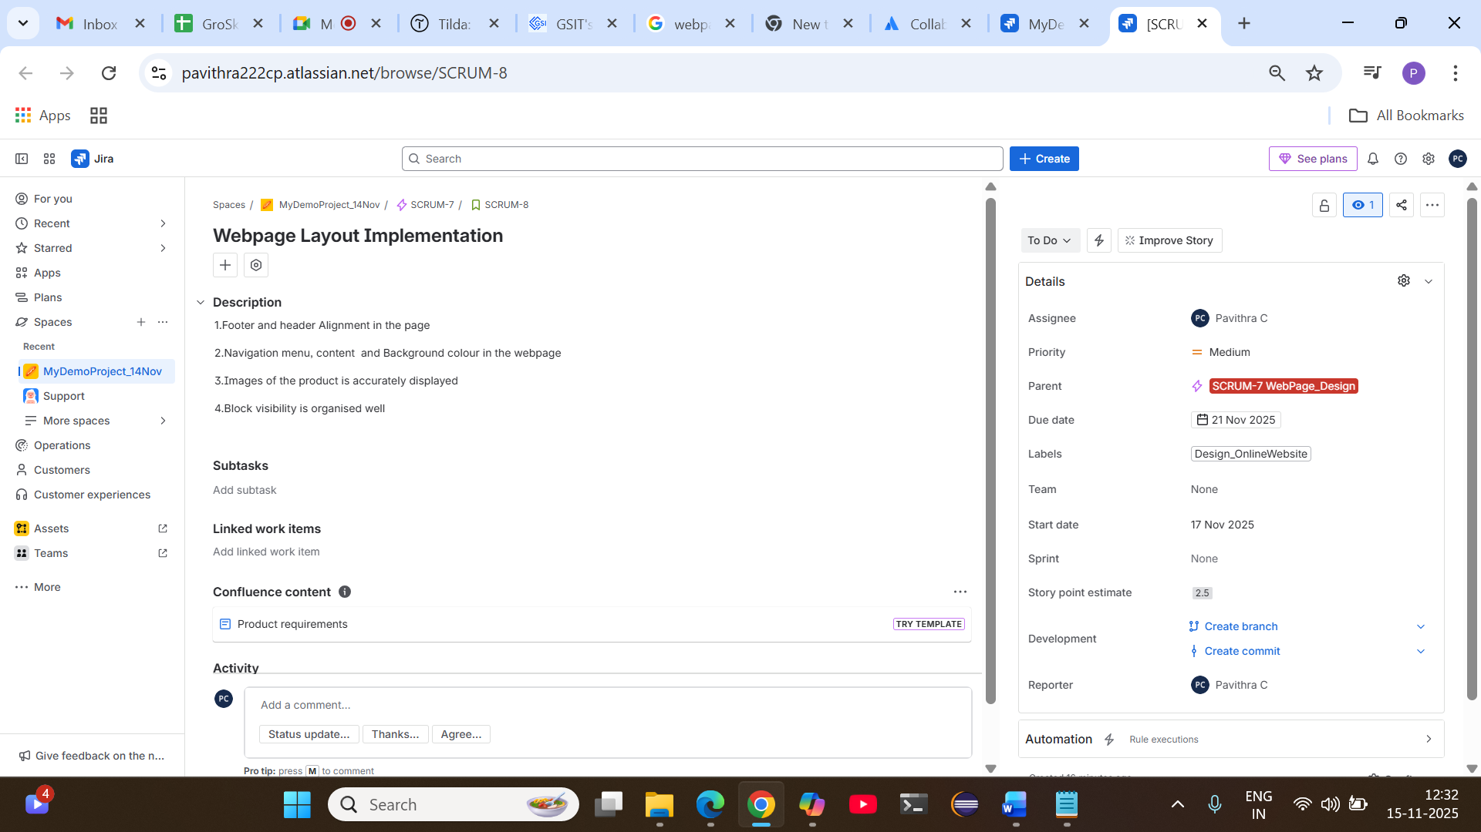

Adding subtask-1 under the user story -Creation of webpage Layout
https://pavithra222cp.atlassian.net/browse/SCRUM-9

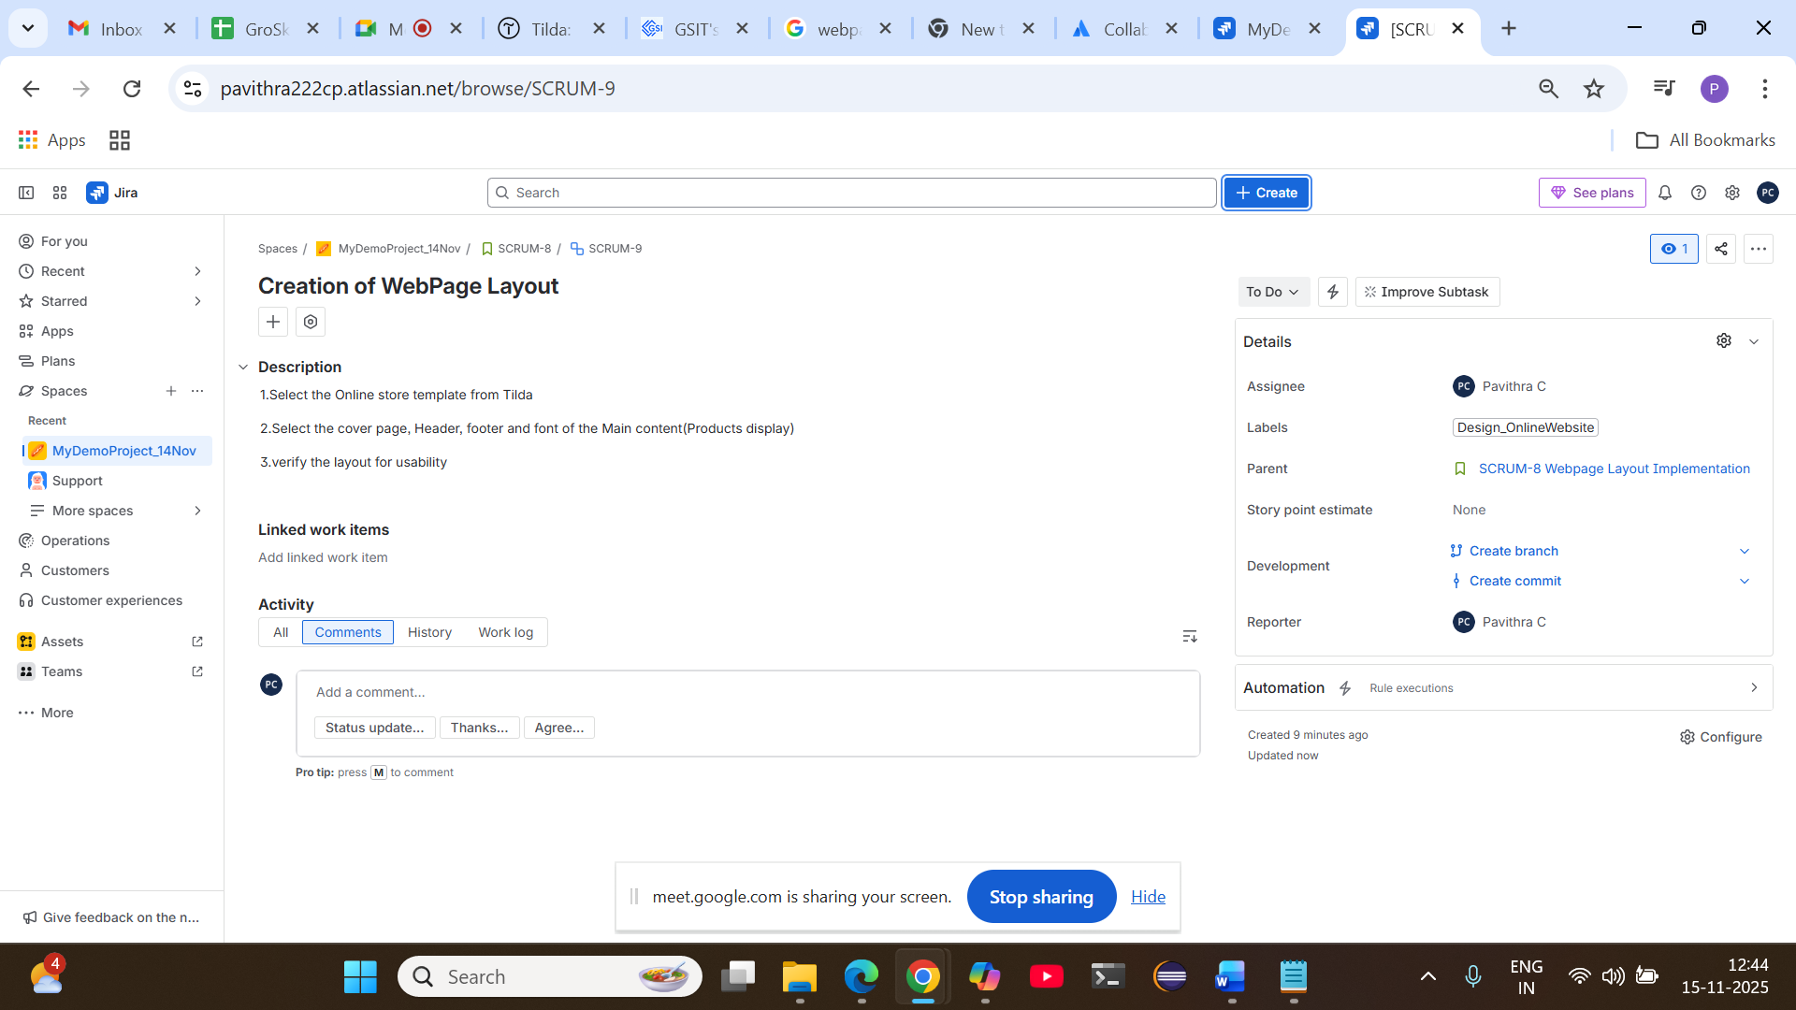Creating EPIC 2- Development
https://pavithra222cp.atlassian.net/browse/SCRUM-10

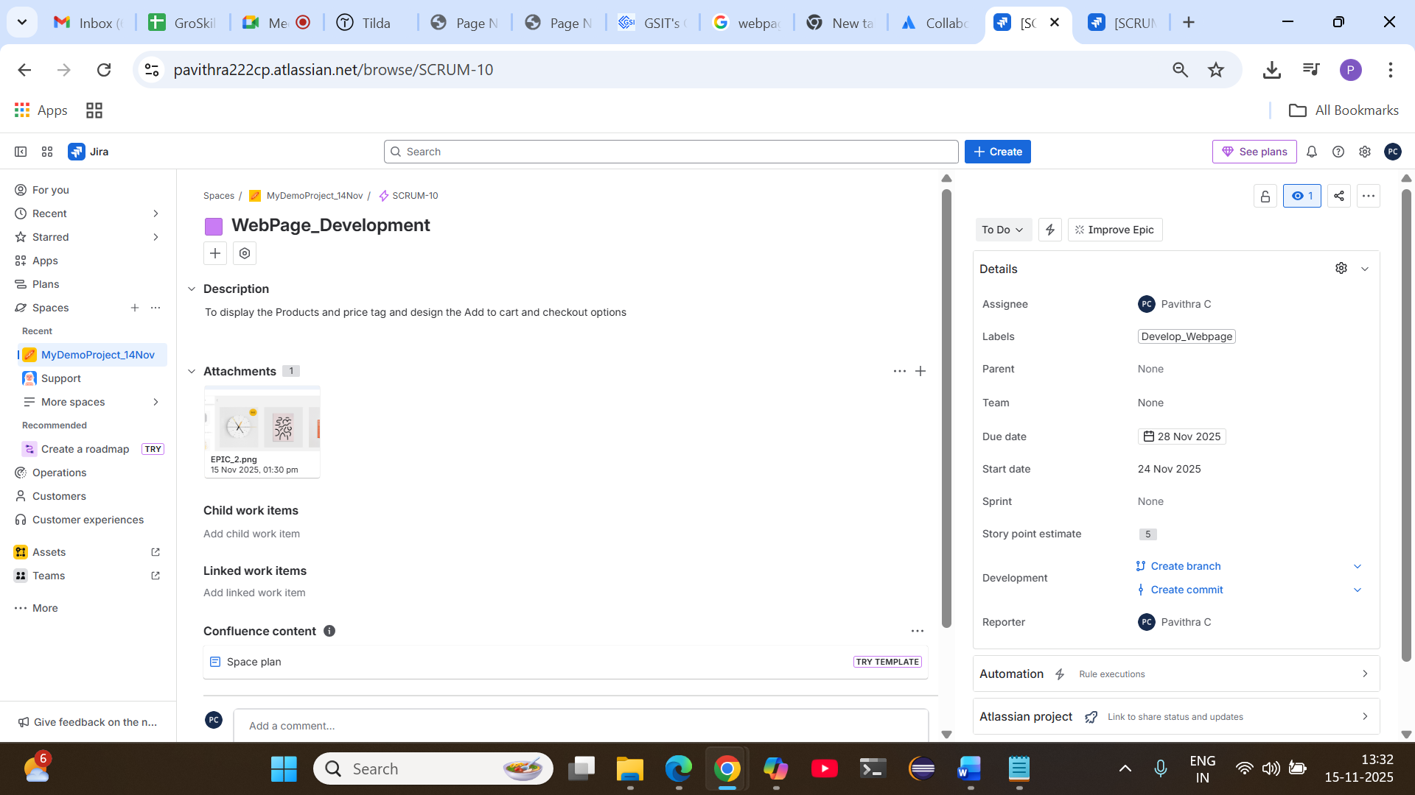

User story
https://pavithra222cp.atlassian.net/browse/SCRUM-11

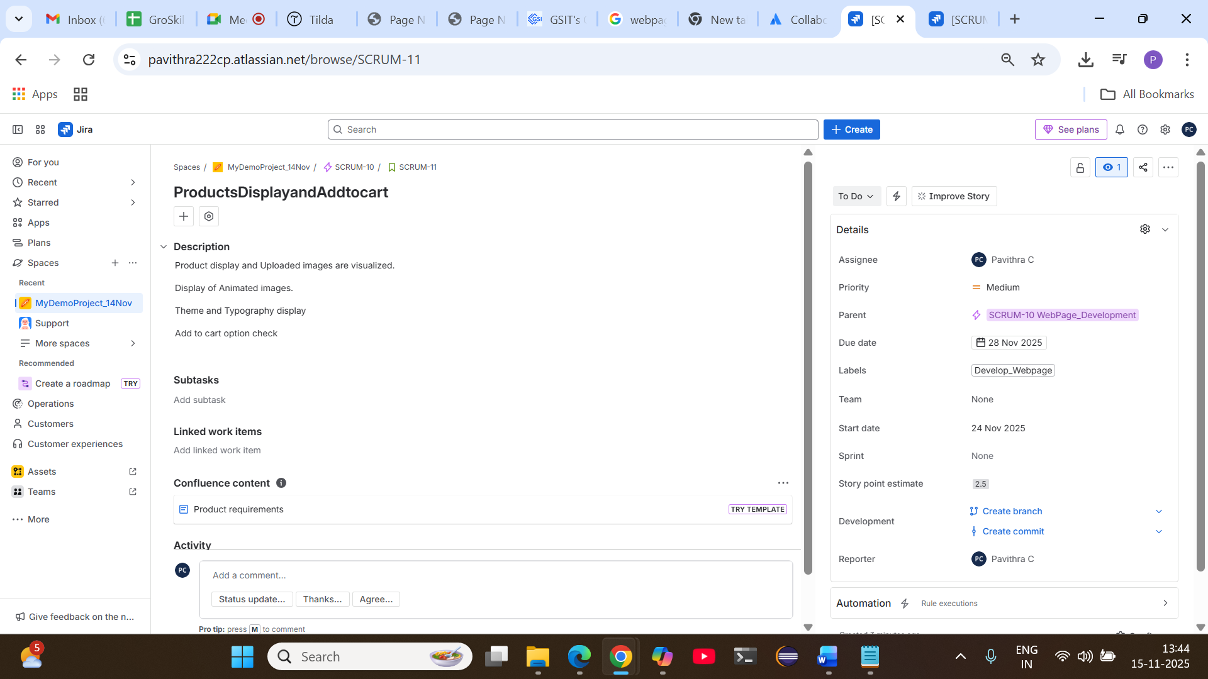
Subtask
https://pavithra222cp.atlassian.net/browse/SCRUM-12
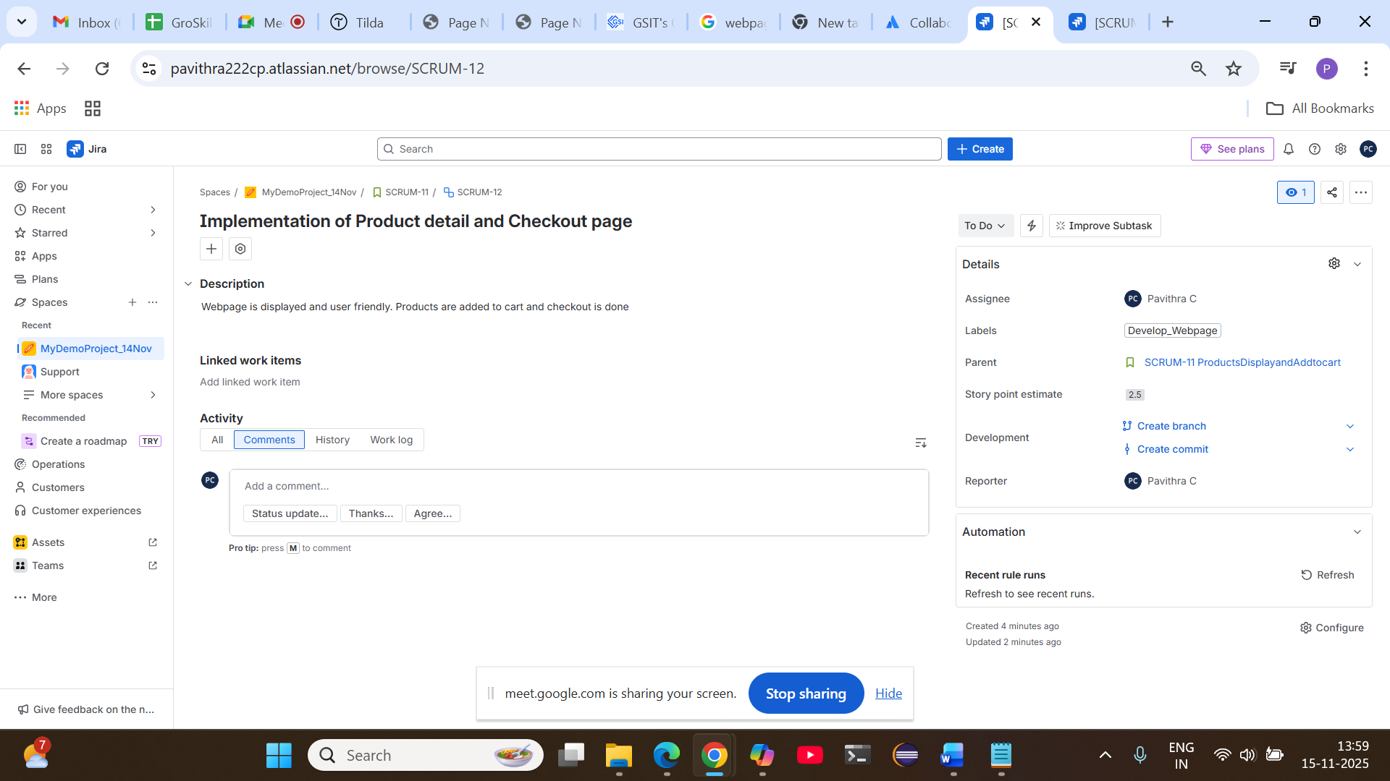

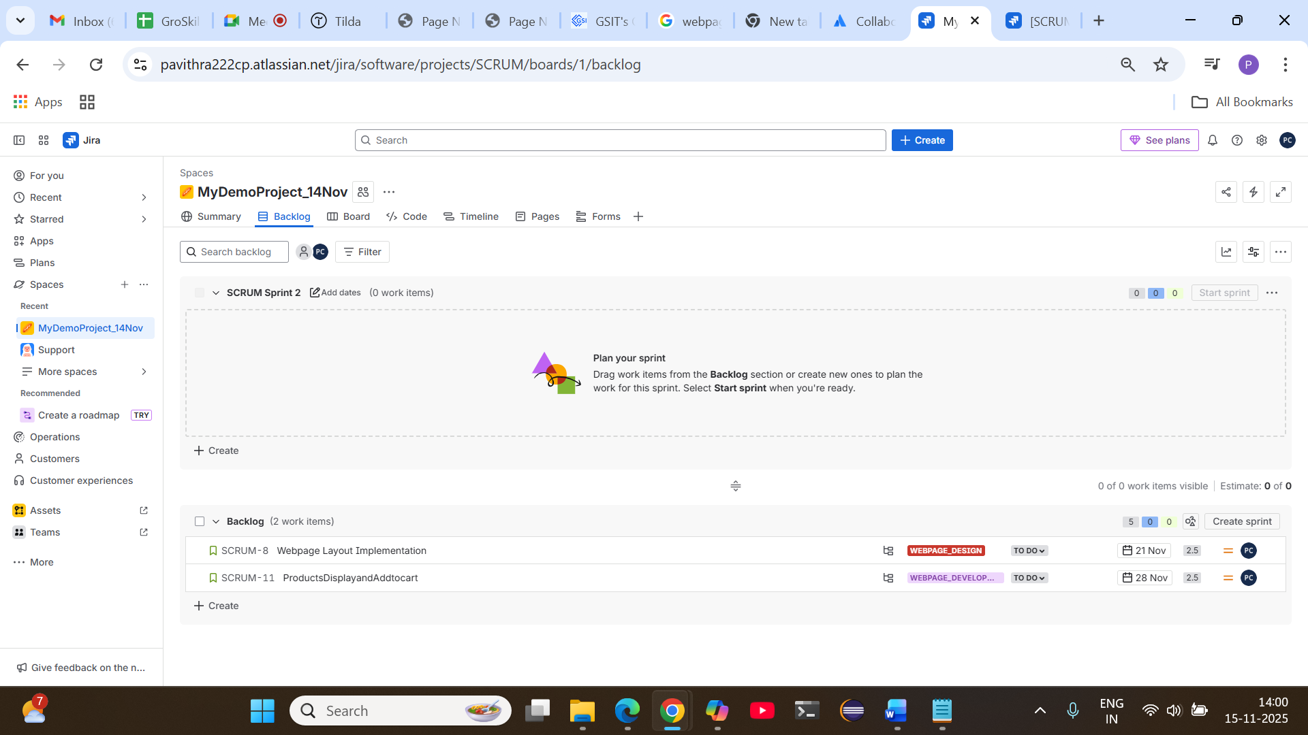
Moving User stories from backlog to sprint
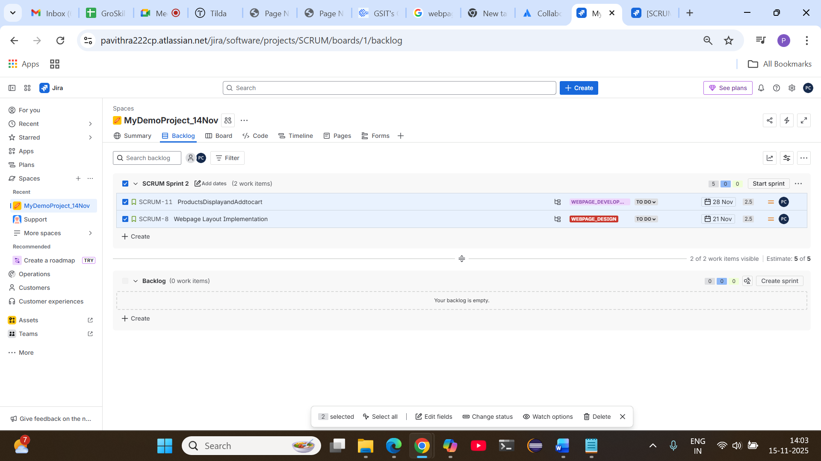

Since date is not updated,date is updated and Start Sprint

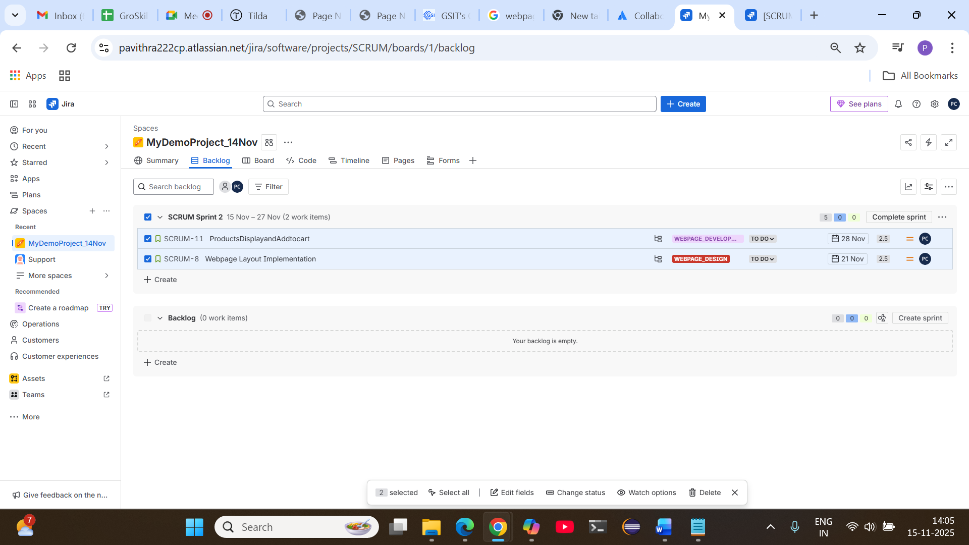
Progress of userstories in board

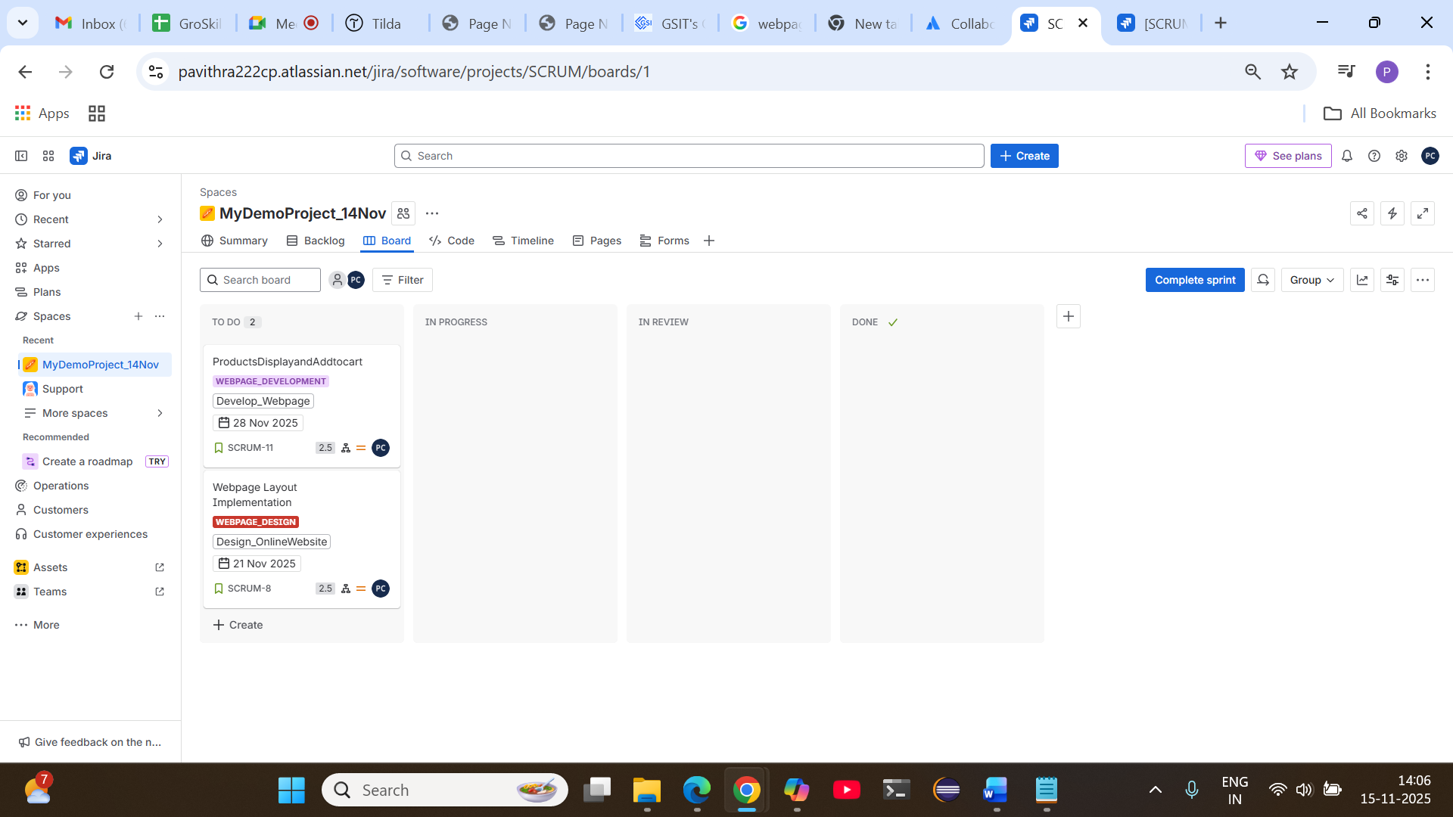

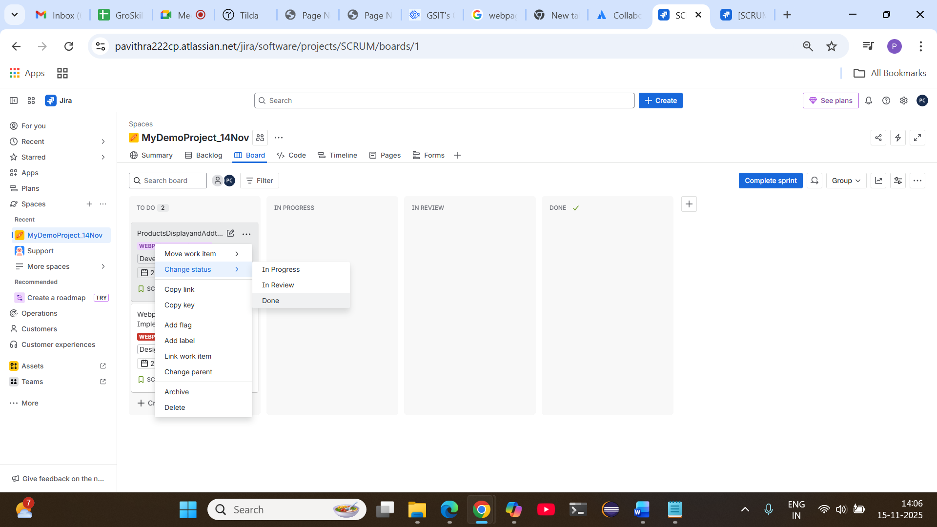

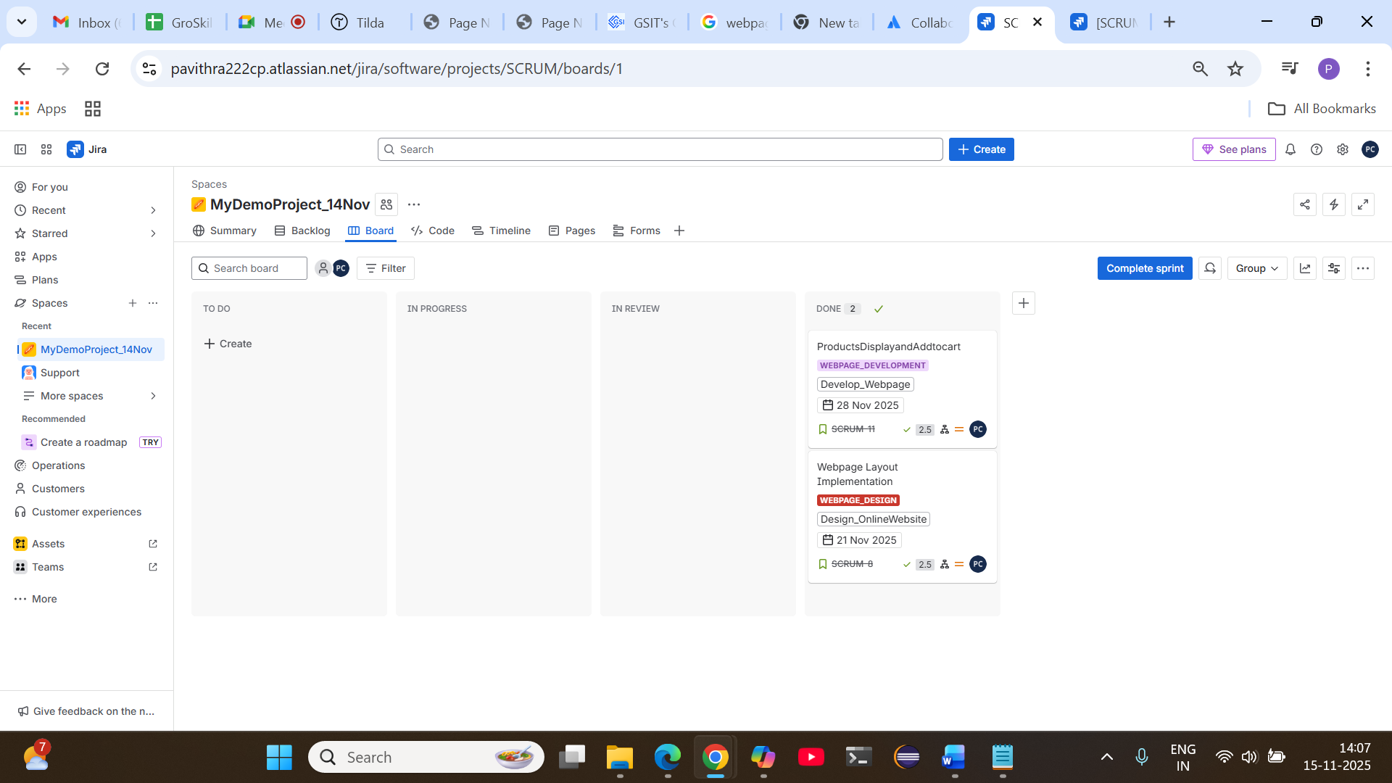

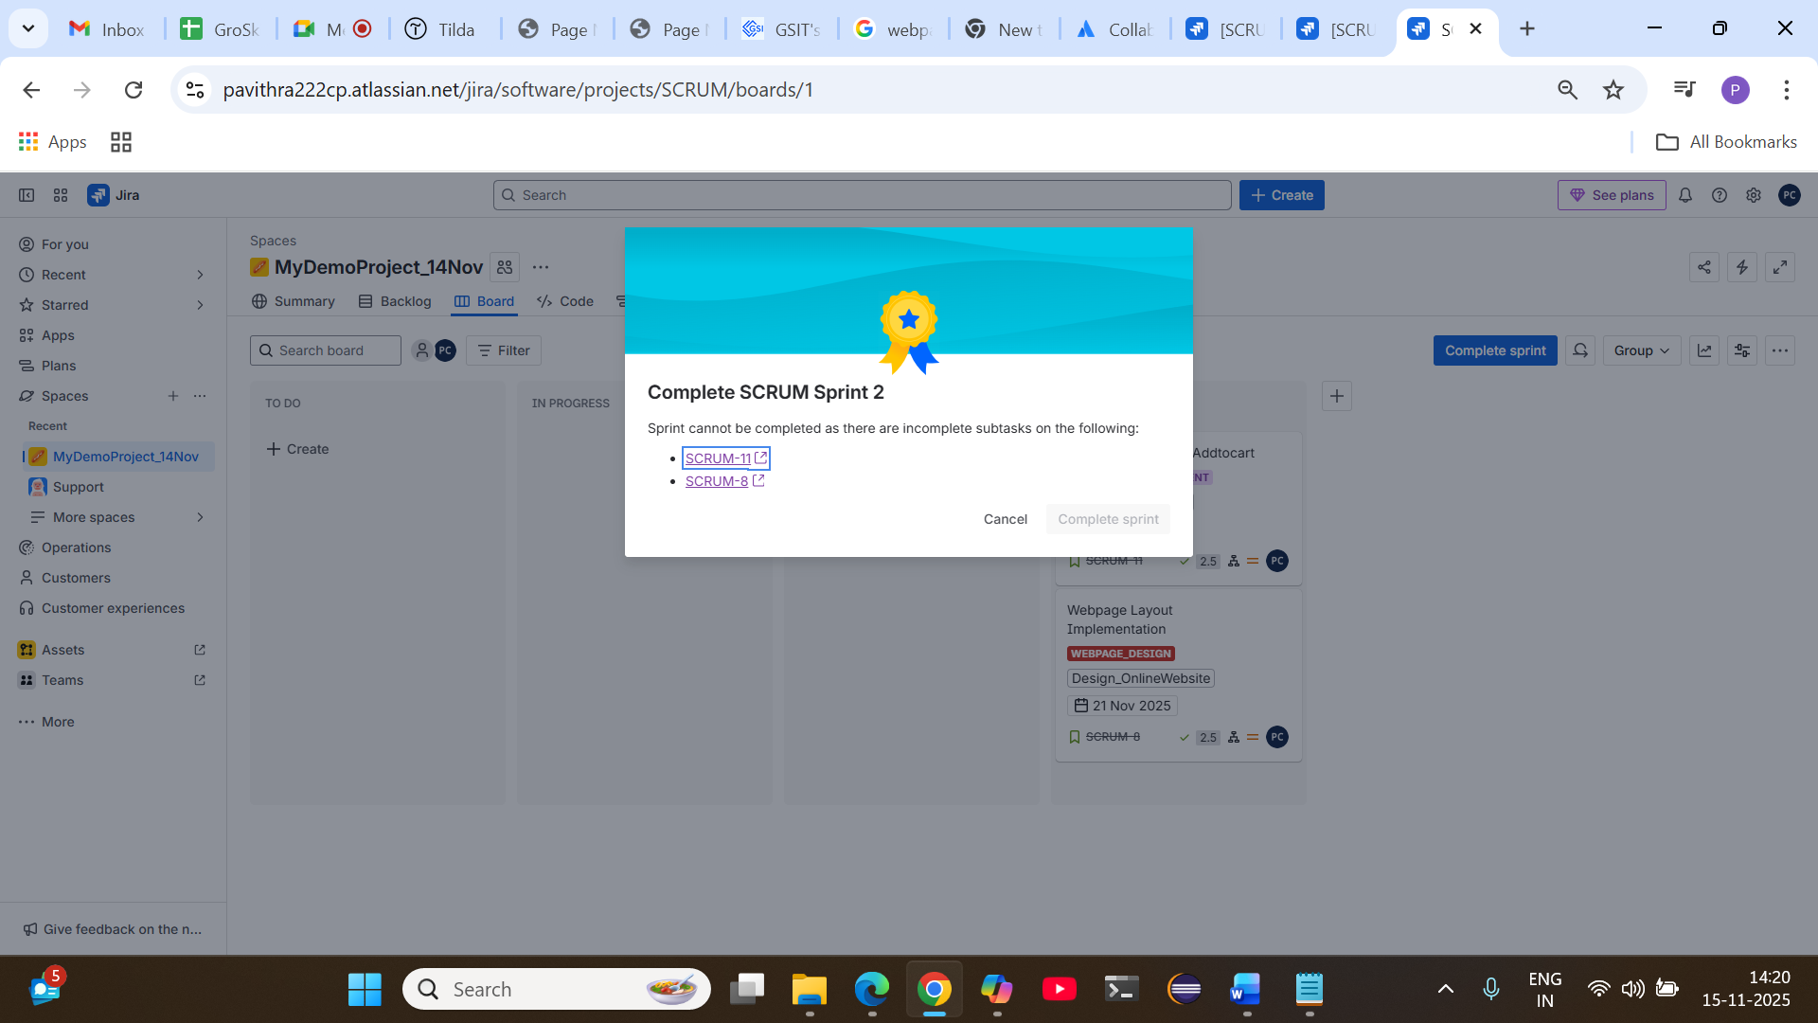
Subtask -done status

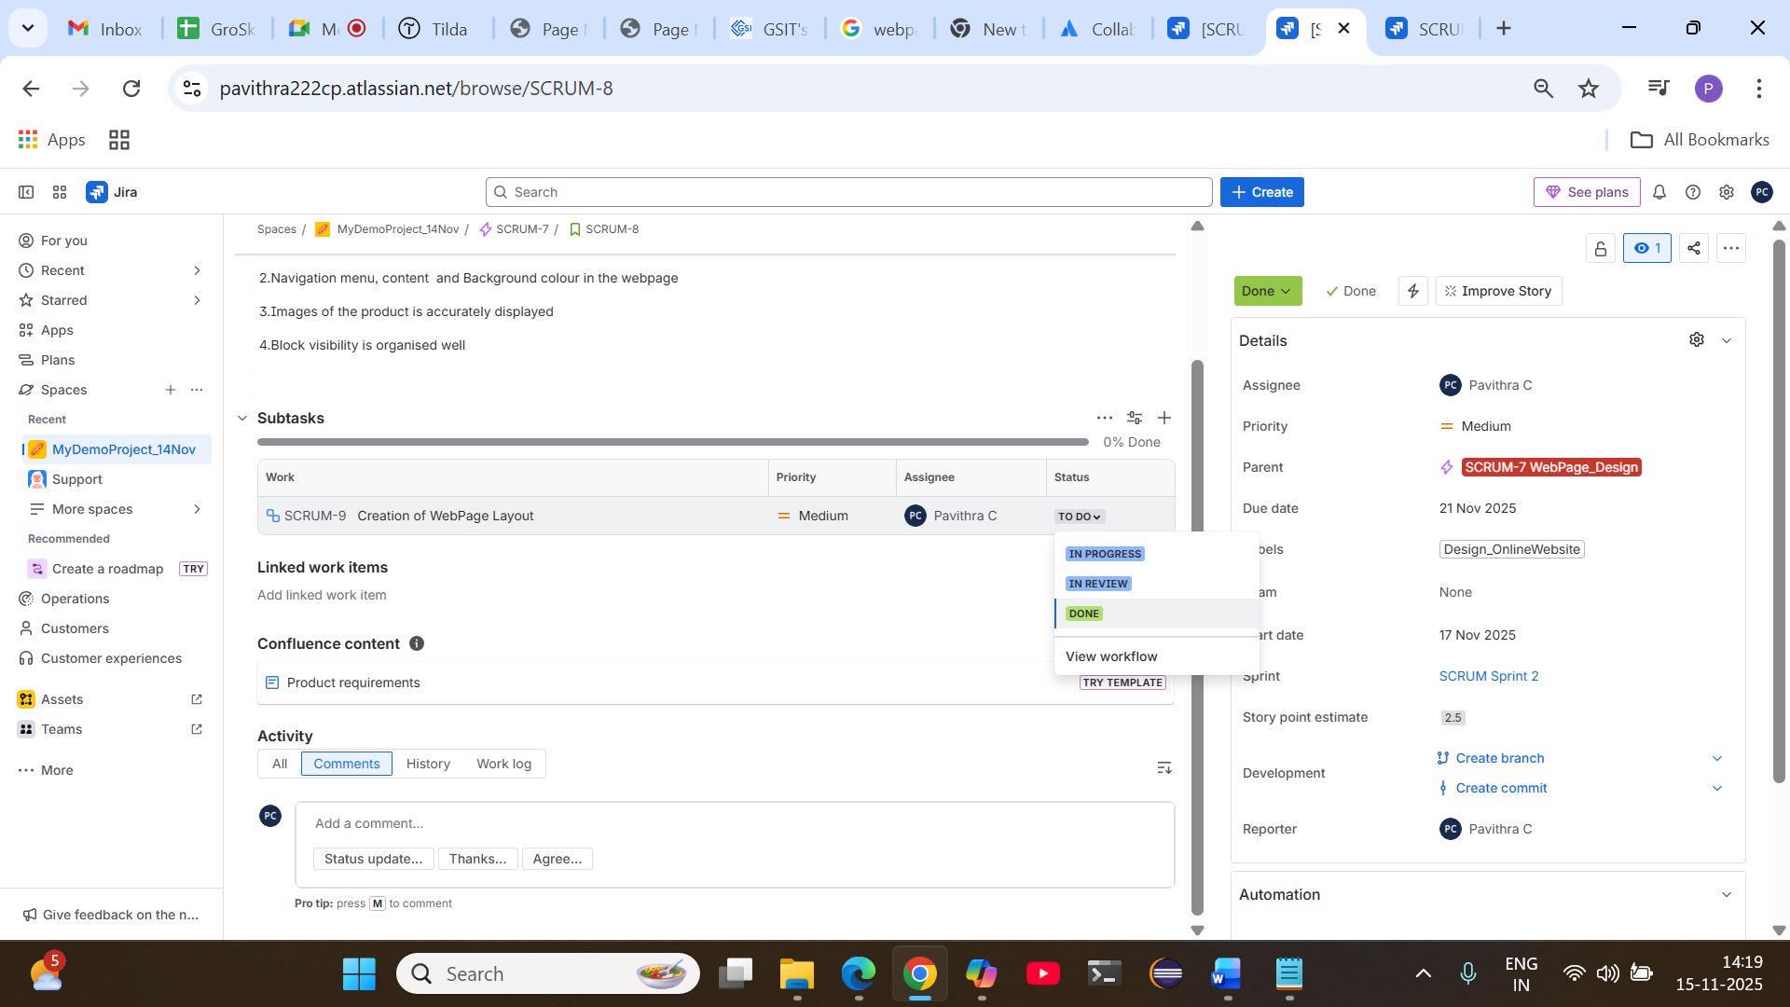

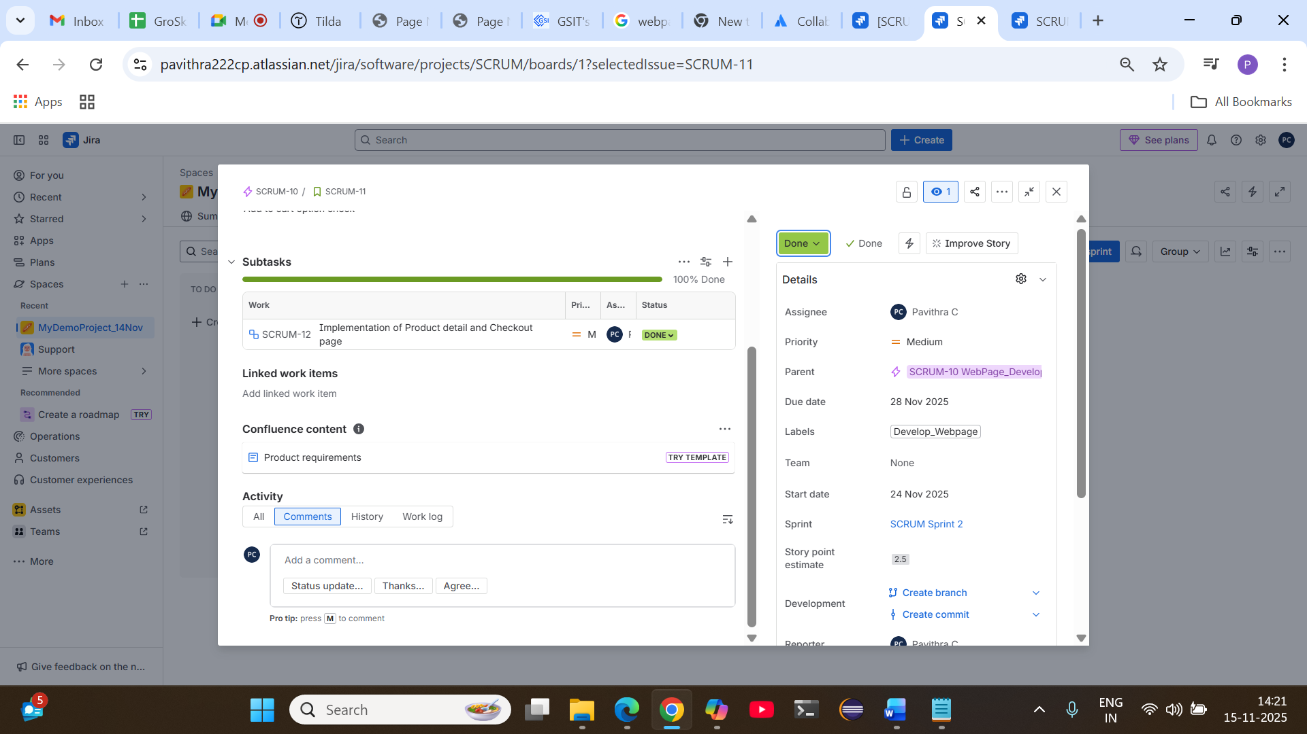
Complete sprint

